Practice Assignment – Layout Managers

- Create the following Layouts:

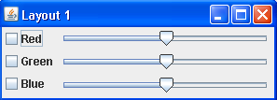
a)

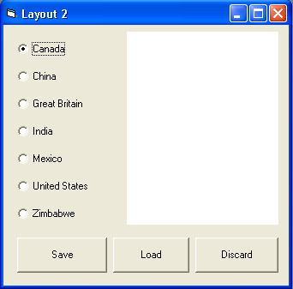b)

- Create a Layout that would be able to play a game of Hangman. Each letter available should be represented by a button. There should be a New Game button and an Exit Button. There should be an image of the hangman and Textbox to show the phrase.

